**IDENTIFYING LAB EQUIPMENT Worksheet**

**Student Name: _______________________________ Period: _______ Date: _____________**

**Write name and the purpose of each lab equipment.**

1. 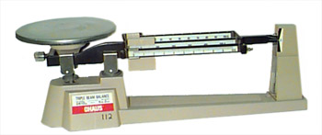 7) 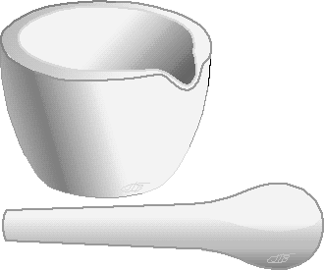
2. 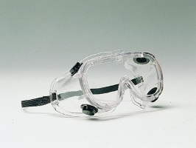 8) 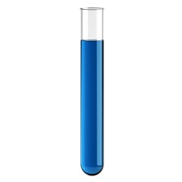
3. 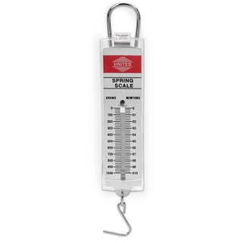 9) 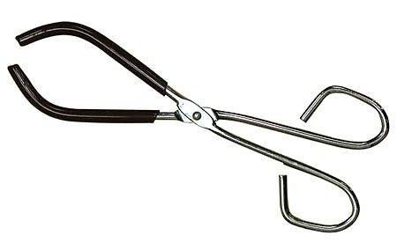
4. 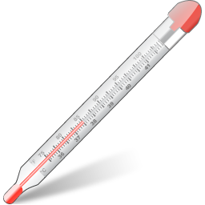 10) 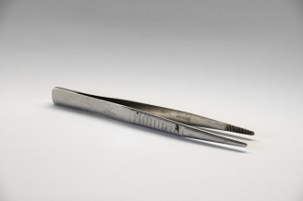
5. 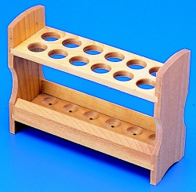 11) 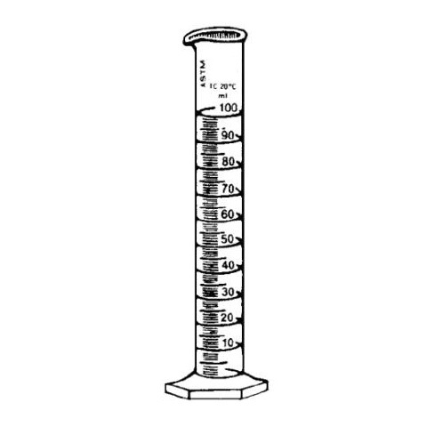

6)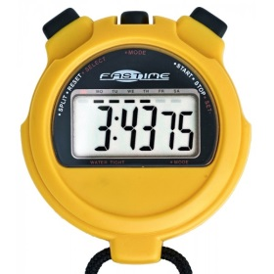 12) 