Lab Equipment Name | Picture | Function/Use
BEAKER | 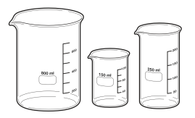 | Container
GRADUATED CYLINDER | 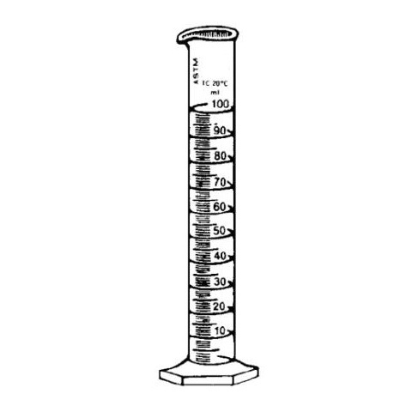 | To measure volume
TEST TUBE | 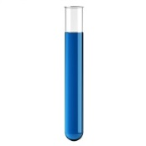 | Container
TEST TUBE HOLDER | 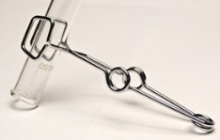 | To hold a test tube
TONGS | 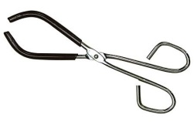 | To pick up and hold lab equipment
TIMER/STOPWATCH | 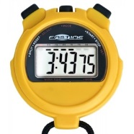 | To time events
SPRING SCALE | 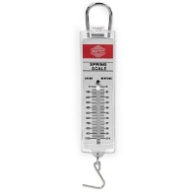 | To measure weight
GOGGLES | 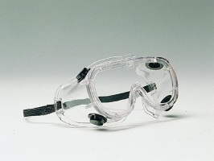 | To protect eyes
THERMOMETER | 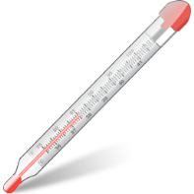 | To measure temperature
TRIPLE BEAM BALANCE | 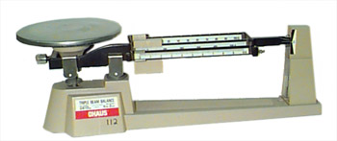 | To measure mass
METRIC RULER | 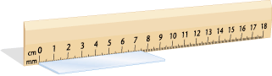 | To measure length
MORTAR & PESTLE | 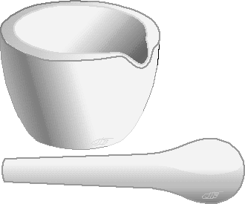 | To crush, grind chemicals to a powder
Lab Equipment Name | Picture | Function/Use
SPATULA | 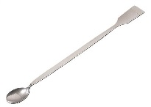 | To transfer solid chemicals
TEST TUBE RACK | 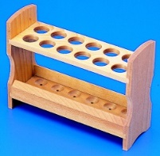 | To hold test tubes in an upright position
TEST TUBE BRUSH | 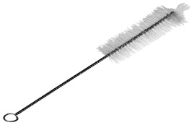 | To scrub test tubes and lab apparatus
FUNNEL | 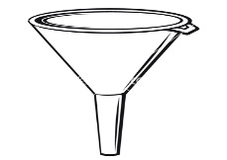 | To hold filter paper, to pour chemicals
MEDICINE DROPPER | 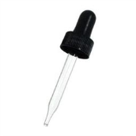 | To dispense small amounts of liquid
FORCEPS | 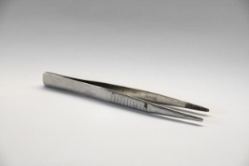 | To pick up or hold small objects
THIN STEM PIPETTE | 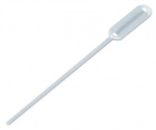 | To transfer small amounts of liquid
HOT PLATE | 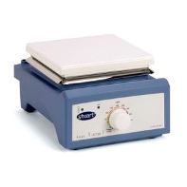 | To heat glassware and its content
FUME HOOD | 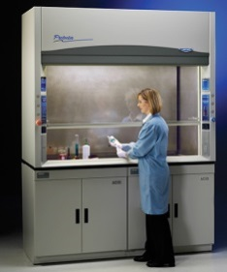 | To limit exposure to hazardous or toxic fumes, vapors or dusts
SCALPEL | 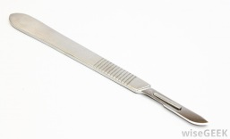 | Surgery, anatomical dissection (To cut open)
ERLENMEYER FLASK | 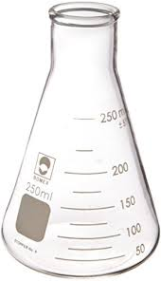 | Container

